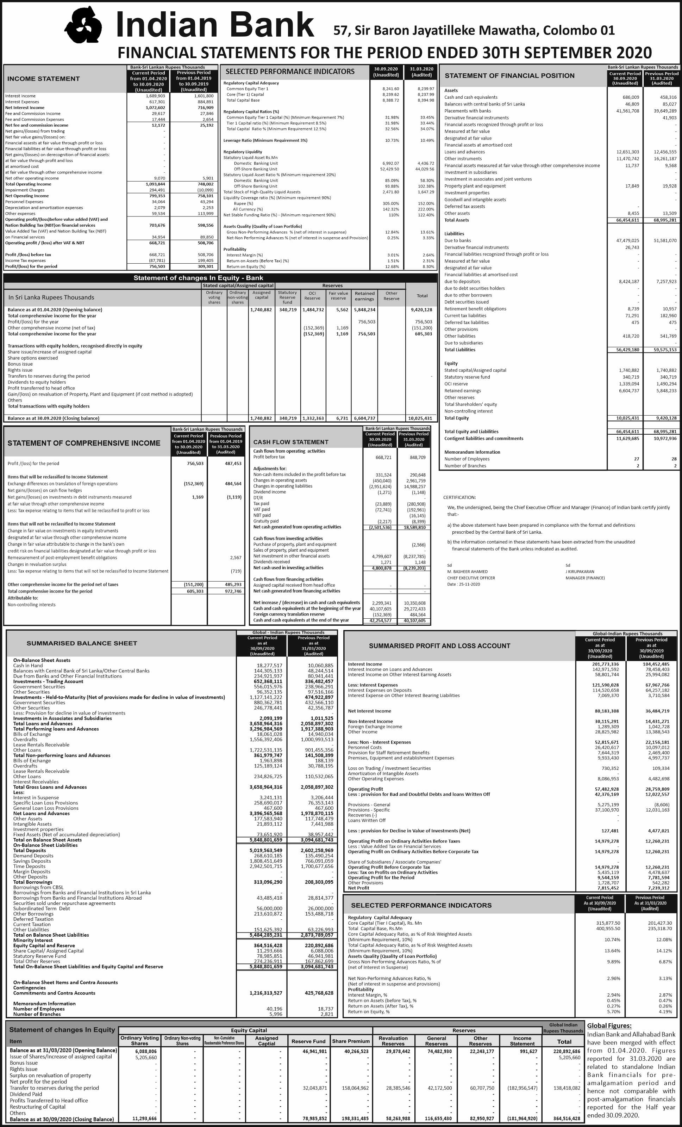
Bank- Sri Lanka Rupees Thousand
Analysis of Loans & Advance | Current Period | Previous Period |  | Analysis of Deposit | Current Period | Previous Period
 | 30.09.2020 | 31.03.2020 |  |  | 30.09.2020 | 31.03.2020
Product-wise Gross loans and advances |  |  |  | By product- Domestic currency
By product-Domestic currency |  |  |  | Demand deposits (Current accounts) | 397,903 | 499,334
Overdrafts | 1,835,545 | 2,149,961 |  | Savings deposits | 247,889 | 234,663
Term loans | 4,040,822 | 3,650,535 |  | Fixed deposits | 1,374,363 | 1,421,946
Other loans | 845,440 | 55,724 |  | Others | 55,851 | 3,357
Sub total | 6,721,806 | 5,856,220 |  | Sub Total | 62,076,006 | 2,159,301
 | -
By product-Foreign currency |  |  |  | By product - Foreign Currency
Overdrafts | 639,018 | 41,323 |  | Demand deposits (Current accounts) | 102,319 | 113,115
Term loans | 6,533,451 | 6,706,900 |  | Savings deposits | 317,666 | 362,954
Other loans | 220,507 | 580,013 |  | Fixed deposits | 5,928,106 | 4,622,553
Trade Finance | 409,920 | 805,030
Sub total | 7,802,896 | 8,133,267 |  | Sub Total | 6,348,181 | 5,098,622
Total | 14,524,702 | 13,989,487 |  | Total | 8,424,187 | 7,257,923

Movement of Impairment during the year | Under stage 1 |  | Under stage 2 |  | Under stage 3
 | 30.09.2020 | 31.03.2020 | 30.09.2020 | 31.03.2020 | 30.09.2020 | 31.03.2020
Opening balance at 01.04.2020 | 143,737 | 156,351 | 10,720 | 1,276 | 1,378,475 | 1,246,583
Charge/(Write back) to income statement | (77,850) | (12,613) | 21,351 | 9,444 | 424,878 | 131,892
Write-off during the year
Other movements |  |  |  |  | (27,912)
Closing balance at 30.09.2020 | 65,887 | 143,737 | 32,071 | 10,720 | 1,775,441 | 1,378,475

Stage-wise impairment during the period | 30.09.2020 | 31.03.2020
Gross loans and advances | 14,524,702 | 13,989,487
Less: Accumulated impairment under stage 1 | 65,887 | 143,737
Accumulated impairment under stage 2 | 32,071 | 10,720
Accumulated impairment under stage 3 | 1,775,441 | 1,378,475
Net loans and advances | 12,651,303 | 12,456,555

Bank - LKR in Thousand | Current Period -30.09.2020 |  |  |  | Previous Period -31.03.2020
ASSETS | AC | FVPL | FVOCI | Total | AC | FVPL | FVOCI | Total
Cash and cash equivalents | 686,009 |  |  | 686,009 | 458,316 |  |  | 458,316
Balances with central banks | 46,809 |  |  | 46,809 | 85,027 |  |  | 85,027
Placements with banks | 41,561,708 |  |  | 41,561,708 | 39,649,289 |  |  | 39,649,289
Derivative financial instruments |  |  |  | - |  | 41,903 |  | 41,903
Loans and advances | 12,651,303 |  |  | 12,651,303 | 12,455,555 |  |  | 12,456,555
Equity instruments |  |  | 11,737 | 11,737 |  |  | 9,568 | 9,568
Other Investments | 11,470,742 |  |  | 11,470,742 | 16,261,187 |  |  | 16,261,187
Others |  |  |  | -
Total financial assets | 66,416,570 | - | 11,737 | 66,428,307 | 68,910,374 | 41,903 | 9,568 | 68,961,844
LIABILITIES | AC | FVPL | FVOCI | Total
Due to banks | 47,479,025 |  |  | 47,479,025 | 51,581,070 |  |  | 51,581,070
Derivative financial instruments |  | 26,743 |  | 26,743
Financial liabilities - due to depositors | 8,424,187 |  |  | 8,424,187 | 7,257,973 |  |  | 7,257,923
Total financial liabilities | 55,903,212 | 26,743 | - | 55,929,955 | 58,838,993 |  |  | 58,838,993

