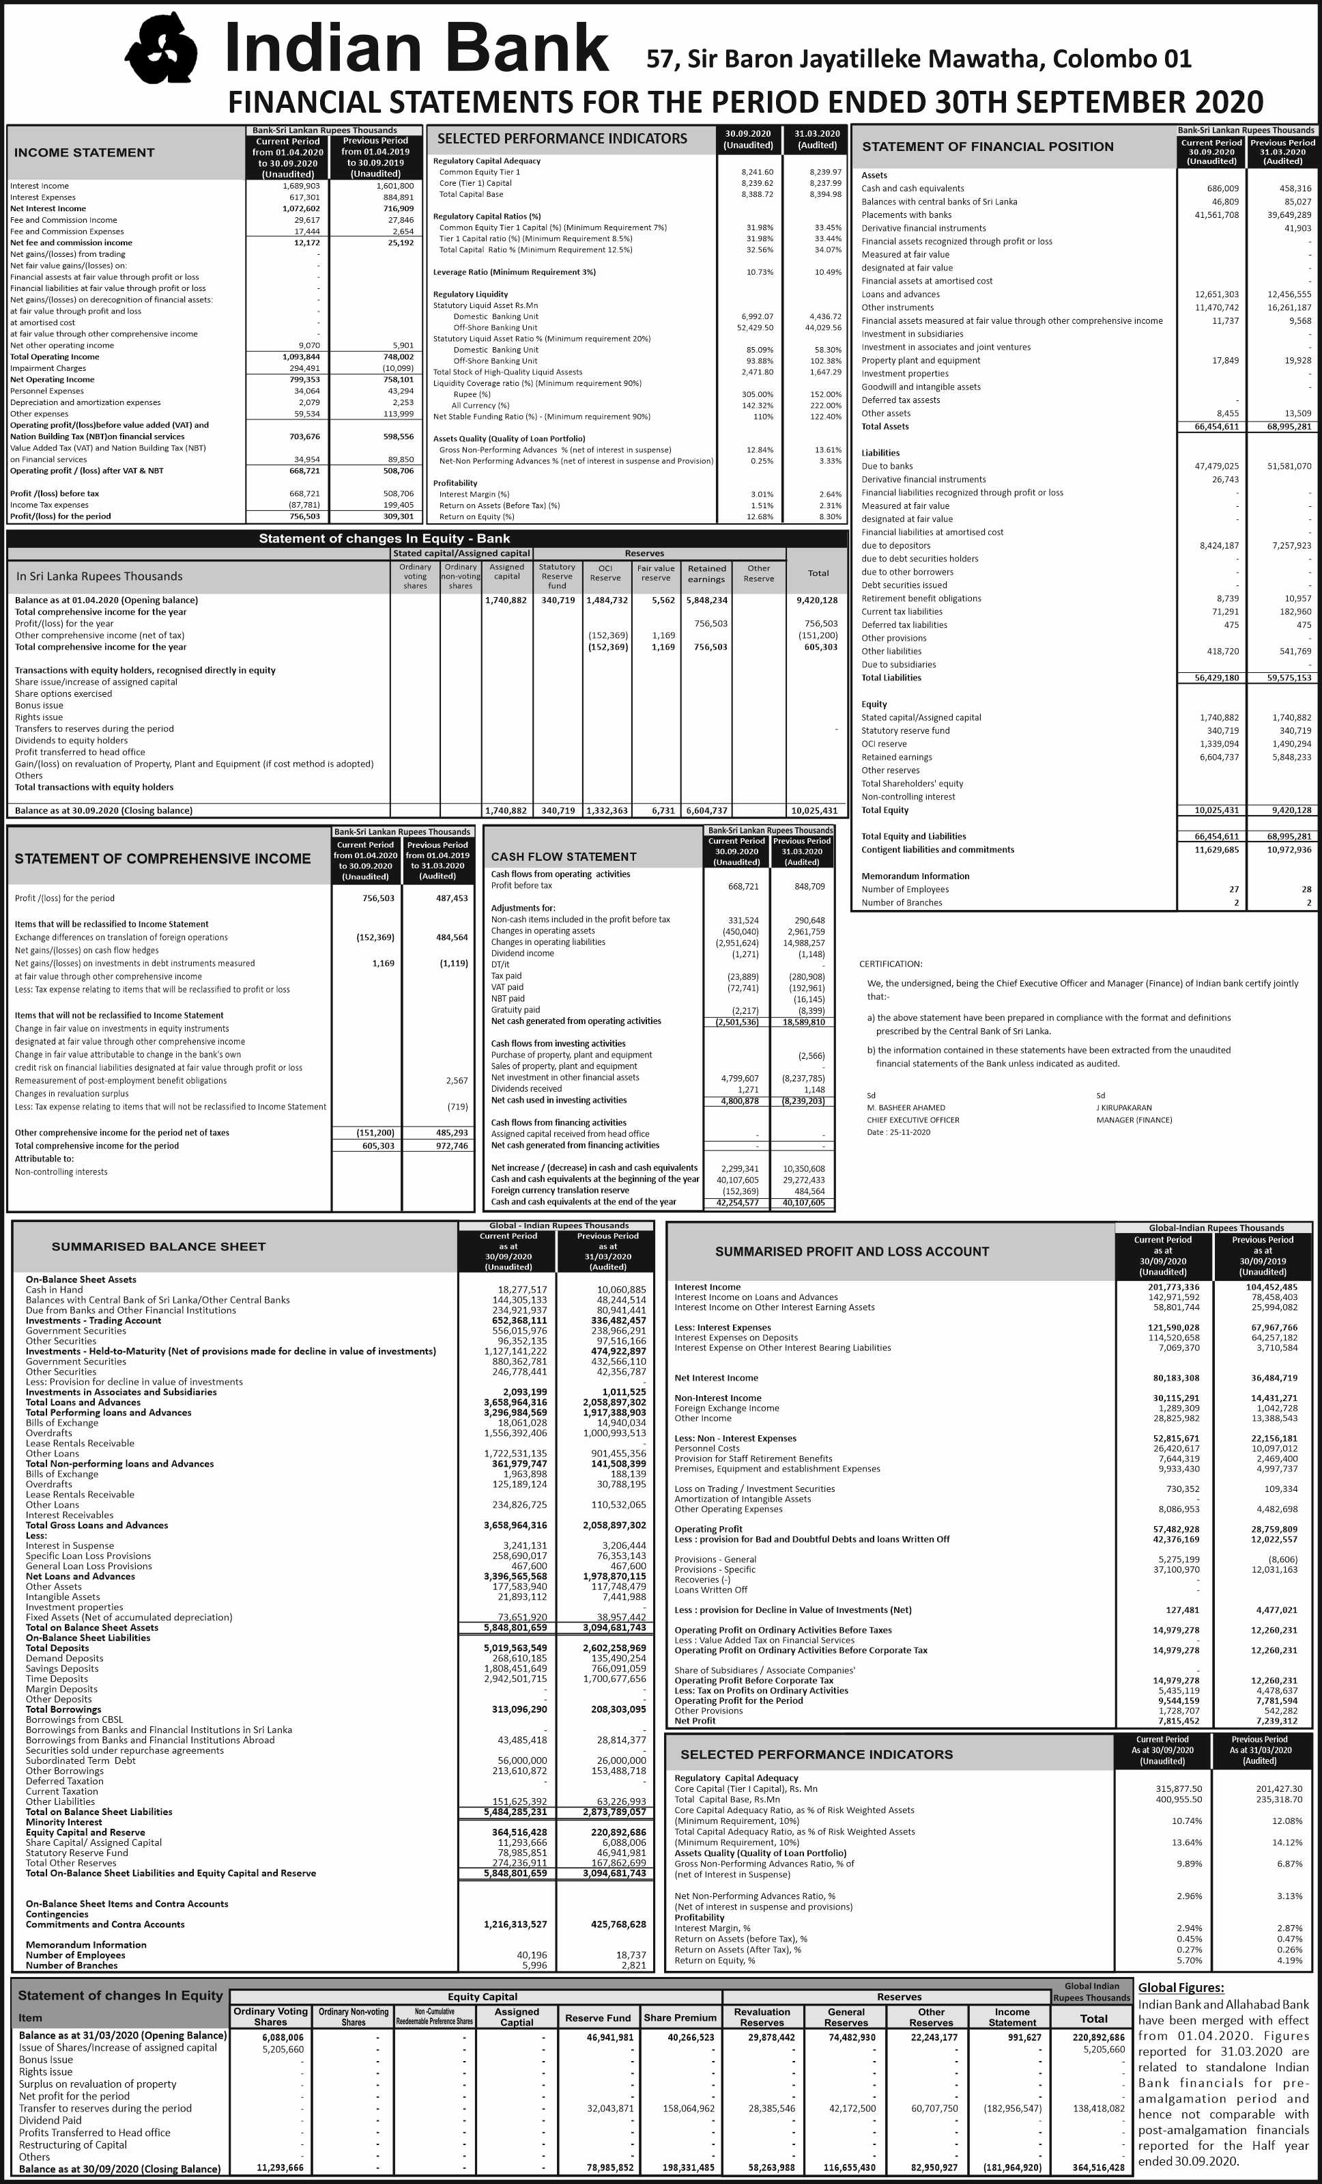

|  |  |  |  |  |  |  |
| --- | --- | --- | --- | --- | --- | --- |
| **Bank- Sri Lanka Rupees Thousand** | | | | | | |
| Analysis of Loans & Advance | **Current Period** | **Previous Period** |  | Analysis of Deposit | **Current Period** | **Previous Period** |
|  | **30.09.2020** | **31.03.2020** |  |  | **30.09.2020** | **31.03.2020** |
| **Product-wise Gross loans and advances** |  |  |  | **By product- Domestic currency** | |  |
| **By product-Domestic currency** |  |  |  | Demand deposits (Current accounts) | 397,903 | 499,334 |
| Overdrafts | 1,835,545 | 2,149,961 |  | Savings deposits | 247,889 | 234,663 |
| Term loans | 4,040,822 | 3,650,535 |  | Fixed deposits | 1,374,363 | 1,421,946 |
| Other loans | 845,440 | 55,724 |  | Others | 55,851 | 3,357 |
| **Sub total** | 6,721,806 | **5,856,220** |  | **Sub Total** | **62,076,006** | **2,159,301** |
|  | - |  |  |  |  |  |
| **By product-Foreign currency** | | |  | **By product - Foreign Currency** | | |
| Overdrafts | 639,018 | 41,323 |  | Demand deposits (Current accounts) | 102,319 | 113,115 |
| Term loans | 6,533,451 | 6,706,900 |  | Savings deposits | 317,666 | 362,954 |
| Other loans | 220,507 | 580,013 |  | Fixed deposits | 5,928,106 | 4,622,553 |
| Trade Finance | 409,920 | 805,030 |  |  |  |  |
| **Sub total** | **7,802,896** | **8,133,267** |  | **Sub Total** | **6,348,181** | **5,098,622** |
| **Total** | **14,524,702** | **13,989,487** |  | **Total** | **8,424,187** | **7,257,923** |

|  |  |  |  |  |  |  |
| --- | --- | --- | --- | --- | --- | --- |
| Movement of Impairment during the year | Under stage 1 | | Under stage 2 | | Under stage 3 | |
|  | 30.09.2020 | 31.03.2020 | 30.09.2020 | 31.03.2020 | 30.09.2020 | 31.03.2020 |
| Opening balance at 01.04.2020 | 143,737 | 156,351 | 10,720 | 1,276 | 1,378,475 | 1,246,583 |
| Charge/(Write back) to income statement | (77,850) | (12,613) | 21,351 | 9,444 | 424,878 | 131,892 |
| Write-off during the year |  |  |  |  |  |  |
| Other movements |  |  |  |  | (27,912) |  |
| Closing balance at 30.09.2020 | **65,887** | **143,737** | **32,071** | **10,720** | **1,775,441** | **1,378,475** |

|  |  |  |
| --- | --- | --- |
| **Stage-wise impairment during the period** | 30.09.2020 | 31.03.2020 |
| **Gross loans and advances** | 14,524,702 | 13,989,487 |
| Less: Accumulated impairment under stage 1 | 65,887 | 143,737 |
| Accumulated impairment under stage 2 | 32,071 | 10,720 |
| Accumulated impairment under stage 3 | 1,775,441 | 1,378,475 |
| **Net loans and advances** | **12,651,303** | **12,456,555** |

|  |  |  |  |  |  |  |  |  |
| --- | --- | --- | --- | --- | --- | --- | --- | --- |
| **Bank - LKR in Thousand** | **Current Period -30.09.2020** | | | | **Previous Period -31.03.2020** | | | |
| **ASSETS** | AC | FVPL | FVOCI | Total | AC | FVPL | FVOCI | Total |
| Cash and cash equivalents | 686,009 |  |  | 686,009 | 458,316 |  |  | 458,316 |
| Balances with central banks | 46,809 |  |  | 46,809 | 85,027 |  |  | 85,027 |
| Placements with banks | 41,561,708 |  |  | 41,561,708 | 39,649,289 |  |  | 39,649,289 |
| Derivative financial instruments |  |  |  | - |  | 41,903 |  | 41,903 |
| Loans and advances | 12,651,303 |  |  | 12,651,303 | 12,455,555 |  |  | 12,456,555 |
| Equity instruments |  |  | 11,737 | 11,737 |  |  | 9,568 | 9,568 |
| Other Investments | 11,470,742 |  |  | 11,470,742 | 16,261,187 |  |  | 16,261,187 |
| Others |  |  |  | - |  |  |  |  |
| **Total financial assets** | **66,416,570** | **-** | **11,737** | **66,428,307** | **68,910,374** | **41,903** | **9,568** | **68,961,844** |
| **LIABILITIES** | AC | FVPL | FVOCI | Total |  |  |  |  |
| Due to banks | 47,479,025 |  |  | 47,479,025 | 51,581,070 |  |  | 51,581,070 |
| Derivative financial instruments |  | 26,743 |  | 26,743 |  |  |  |  |
| Financial liabilities - due to depositors | 8,424,187 |  |  | 8,424,187 | 7,257,973 |  |  | 7,257,923 |
| **Total financial liabilities** | **55,903,212** | **26,743** | **-** | **55,929,955** | **58,838,993** |  |  | **58,838,993** |